I. Provision resource using terraform

Step 1: terraform init

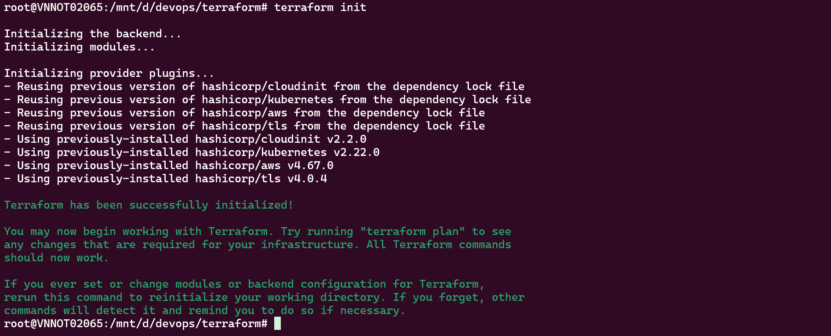Step 2: terraform apply

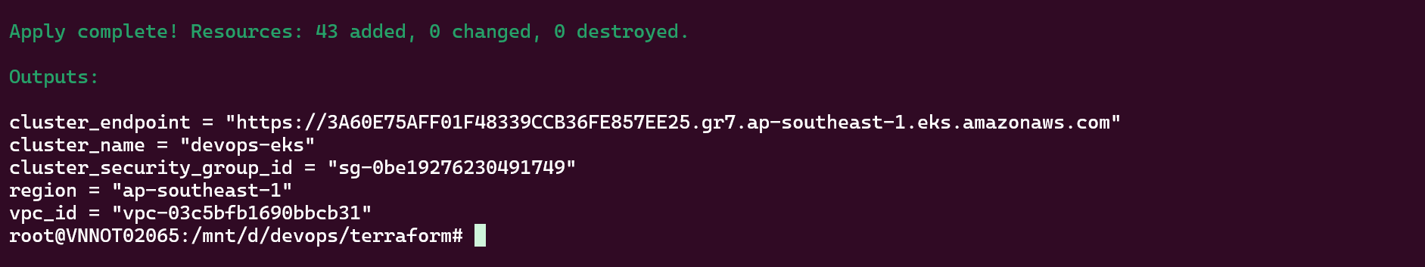

Step 3: Check resources

EC2 installed Jenkins

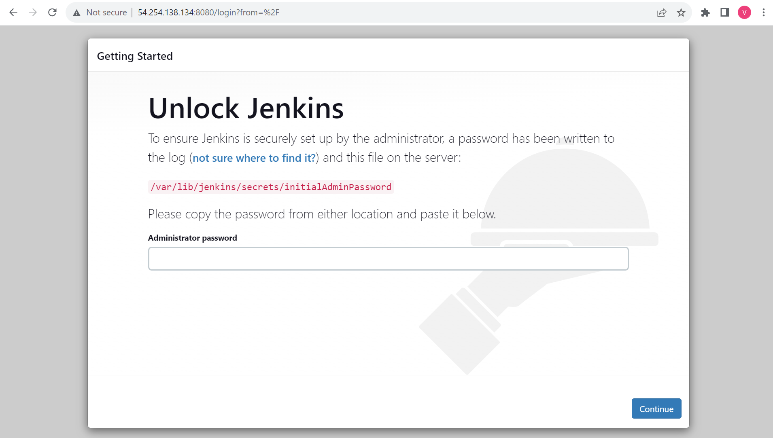

ECR repositories

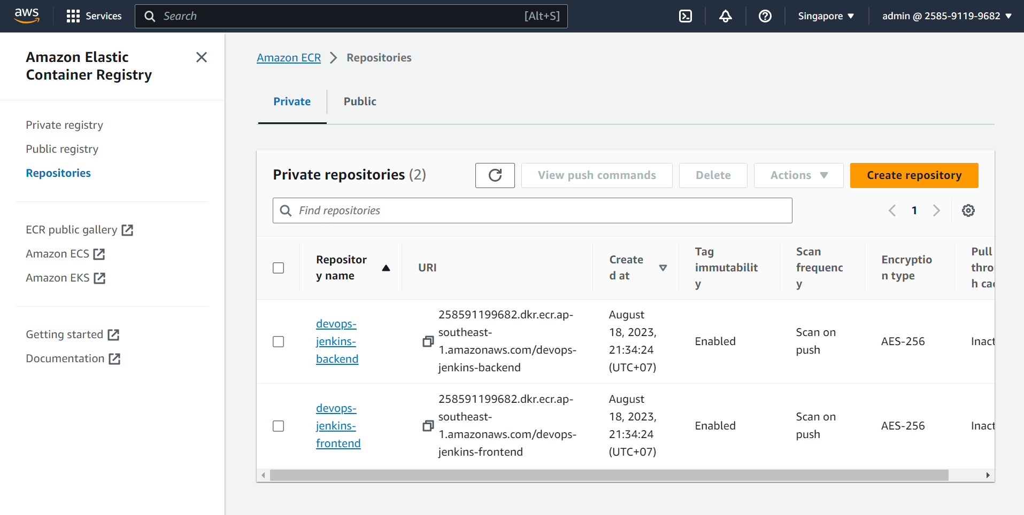

EKS cluster

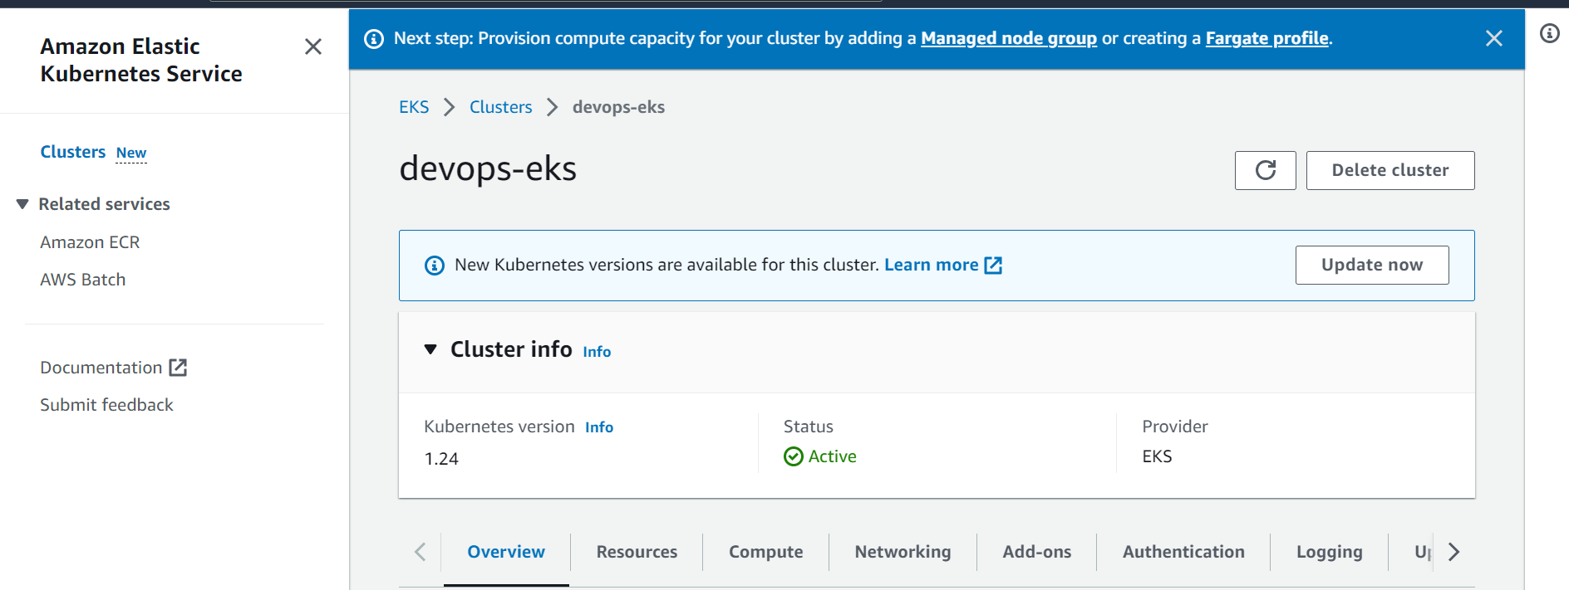

II. Setup Jenkins

Step 1: Install plugin

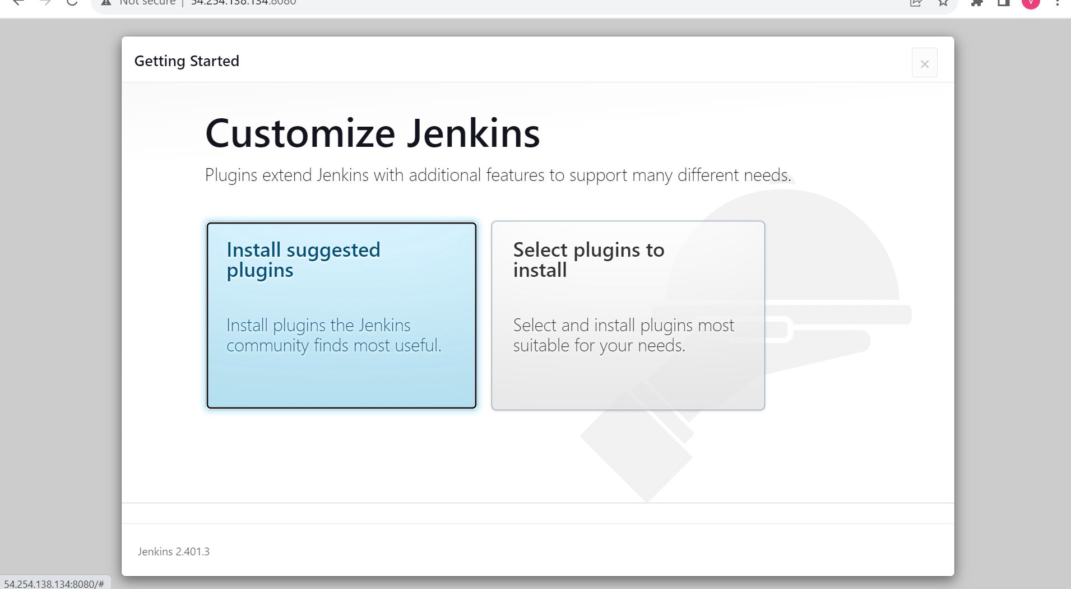

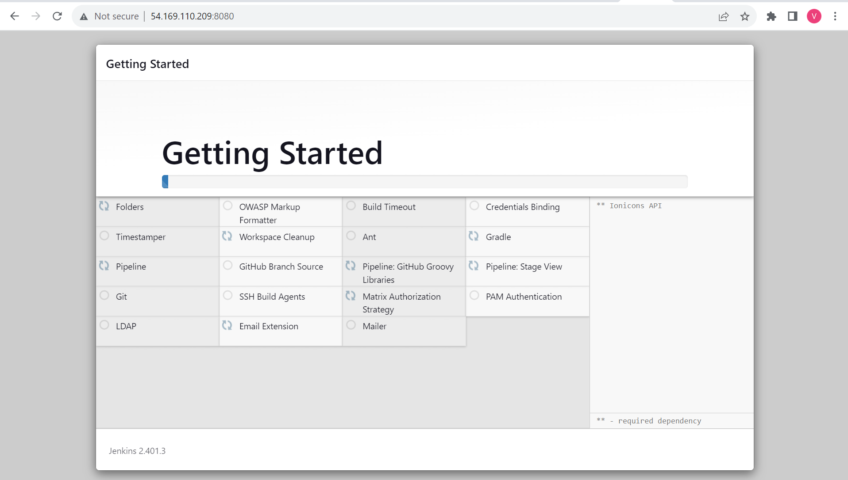

Step 2: Create admin user

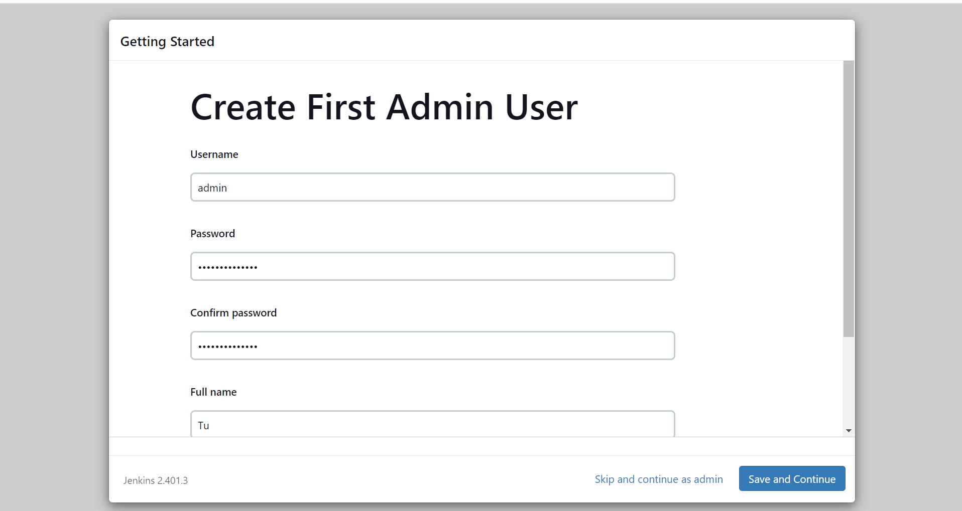

Step 3: Install tool for docker and Kubernetes

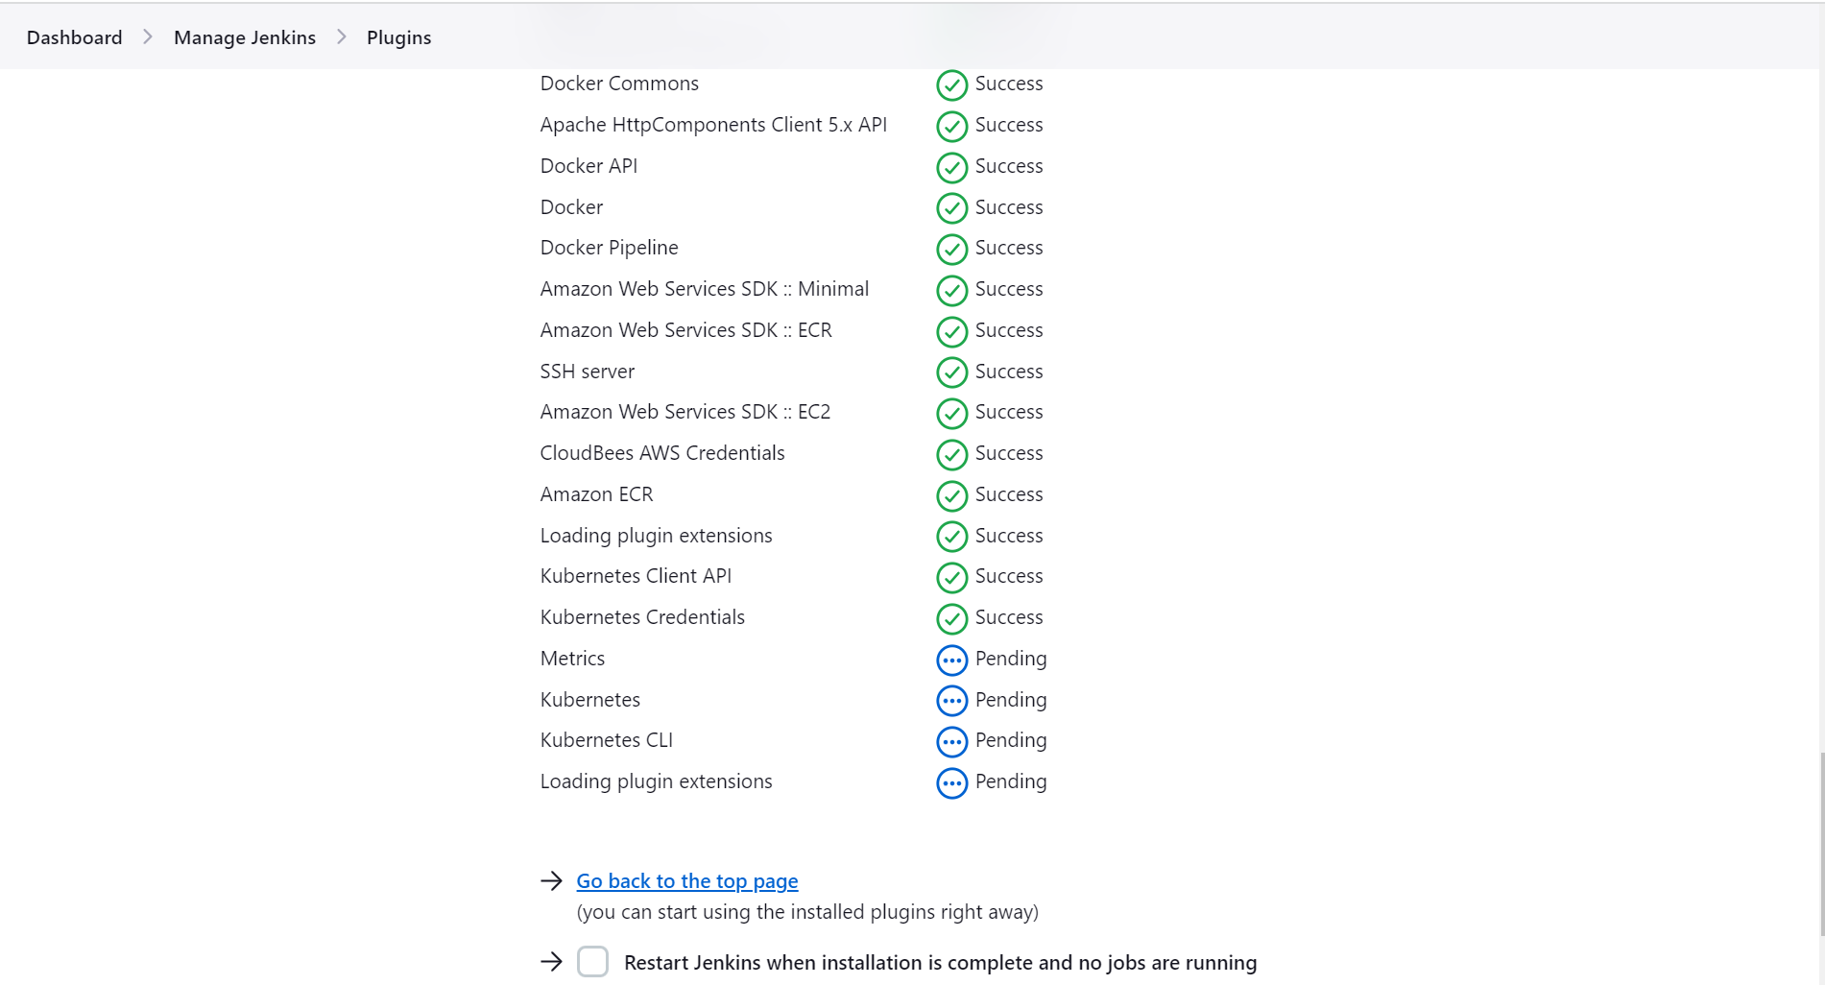

Step 4: Add credentials

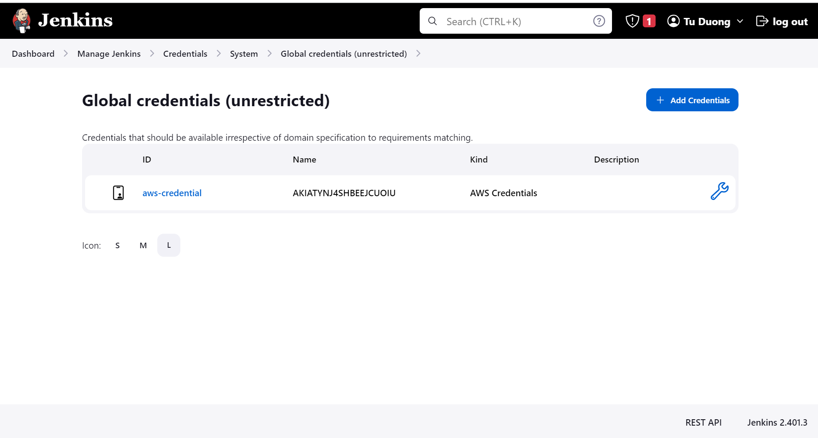

Step 5: Create a pineline

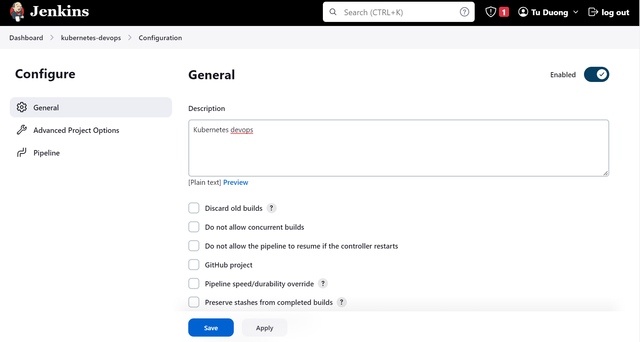

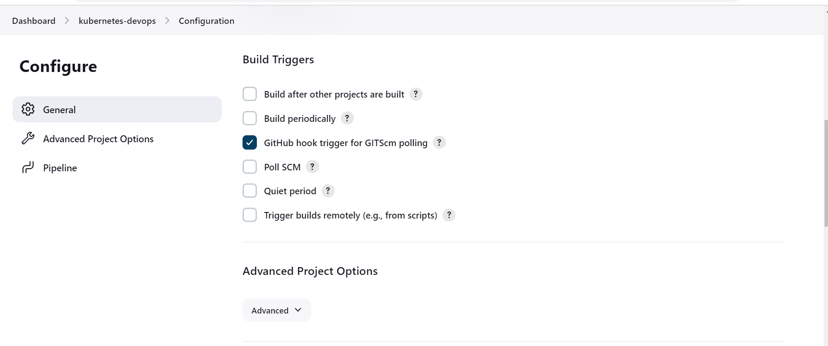

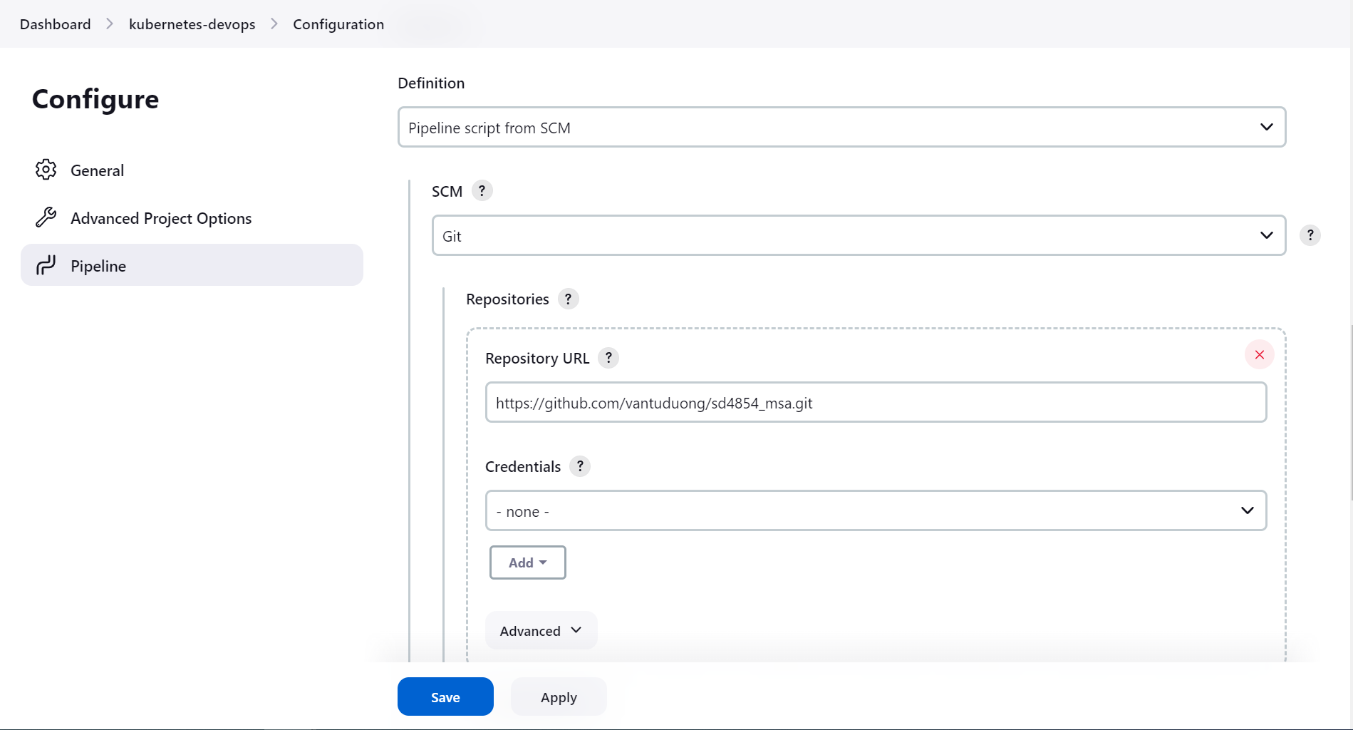

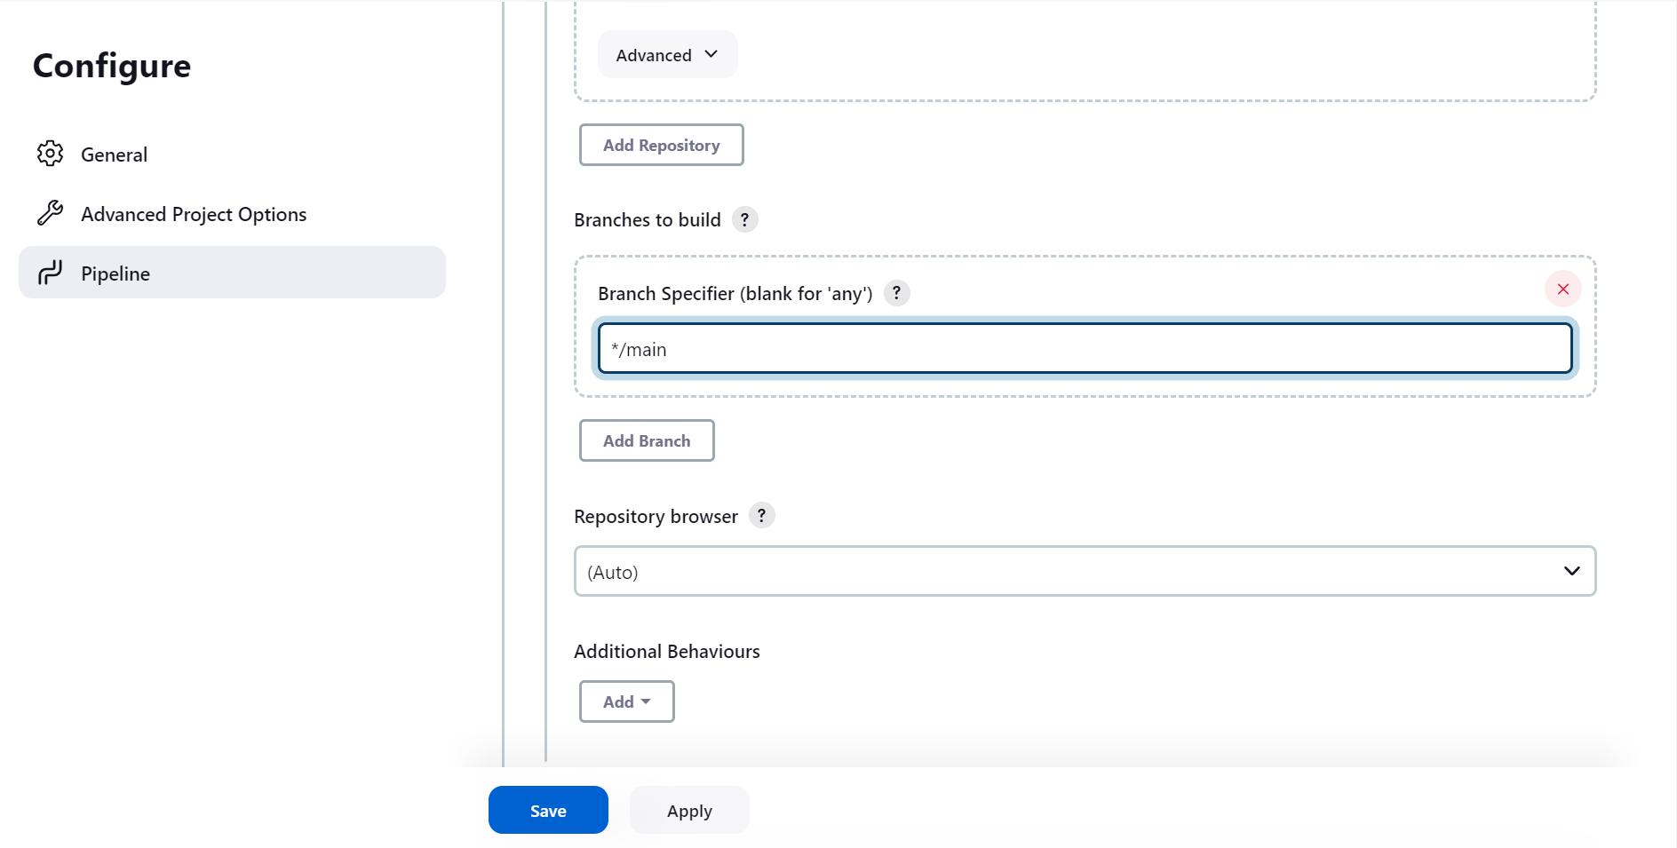

Step 5: Add github webhook

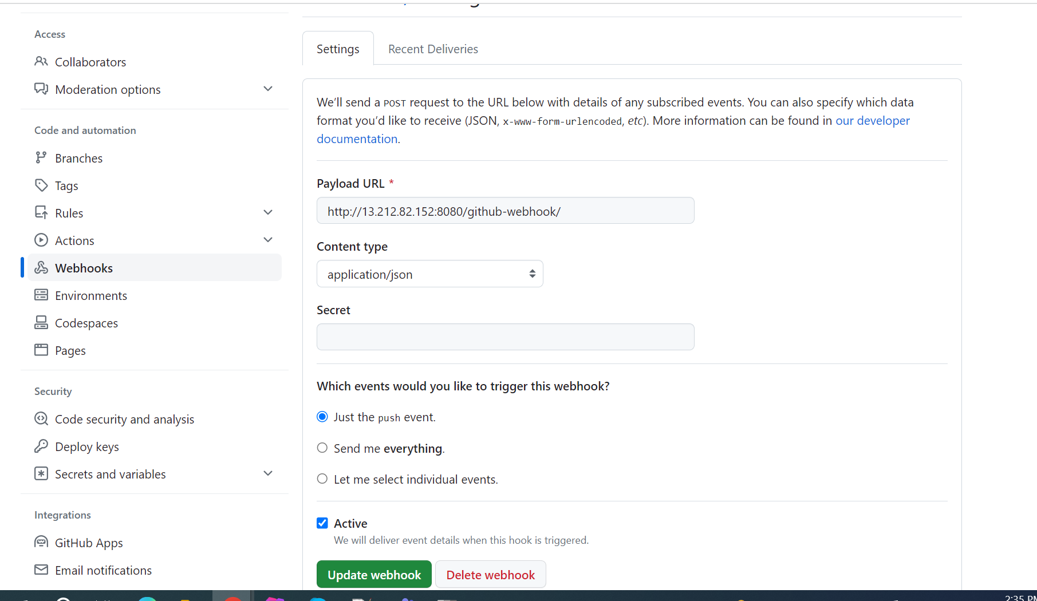

Step 6: Write Jenkin Pipeline

Check in repo: <https://github.com/vantuduong/sd4854_msa>

Step 7: Config aws credential and update kube config for jenkins user



Step 8: Commit code to **main** branch & wait for pipeline run complete

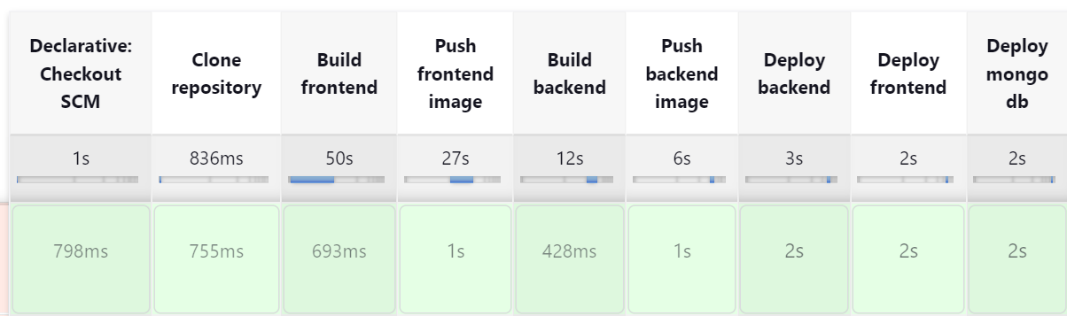

Step 9: Forward port



Step 10: Check result

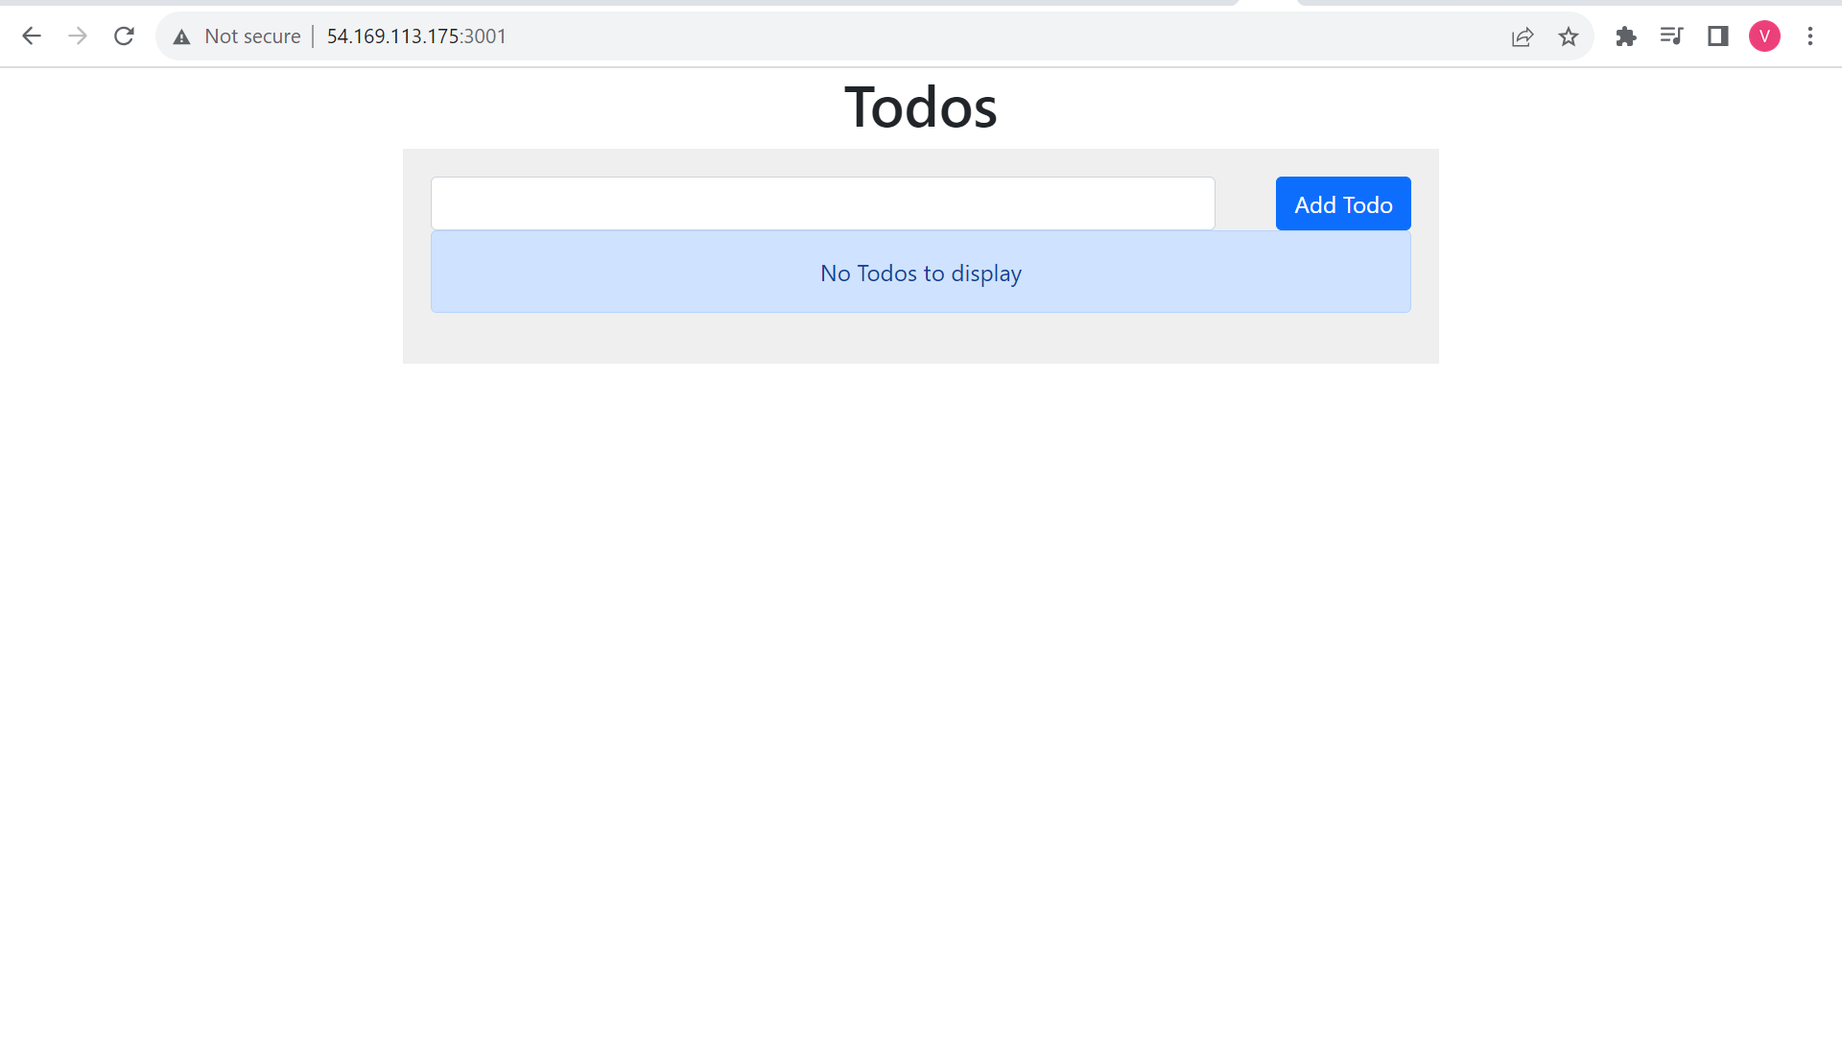

III. Setting ArgoCD

Step 1: Create namespace and install argocd into cluster

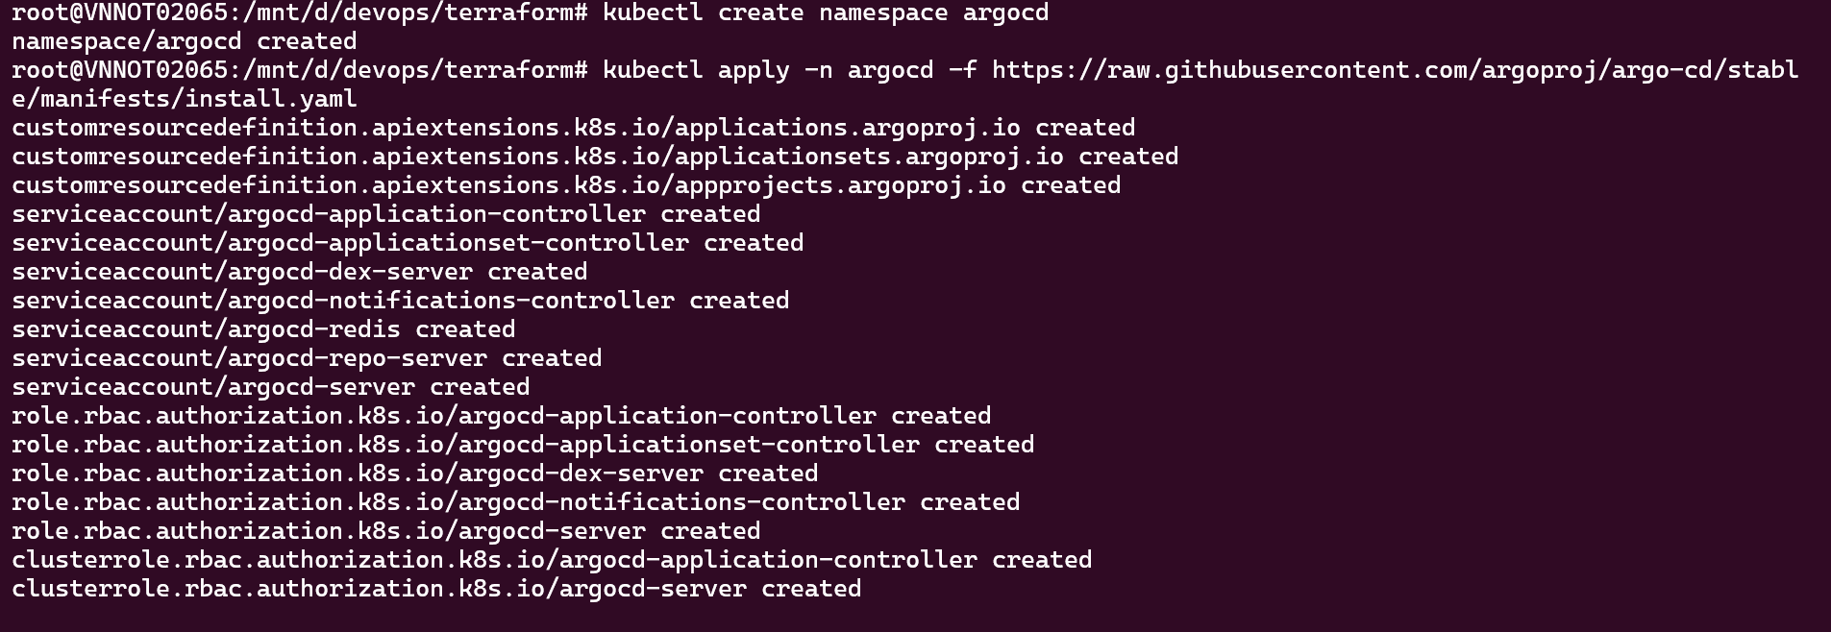

Step 2: Check pods running

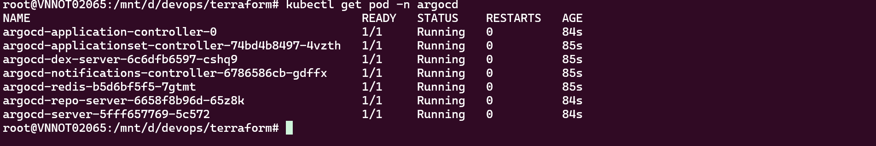

Step 3: Get initial admin password



Step 4: Forward port to run on local

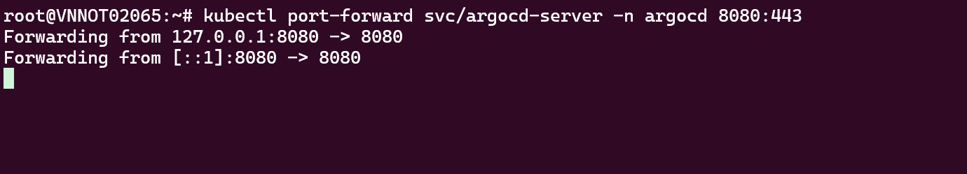

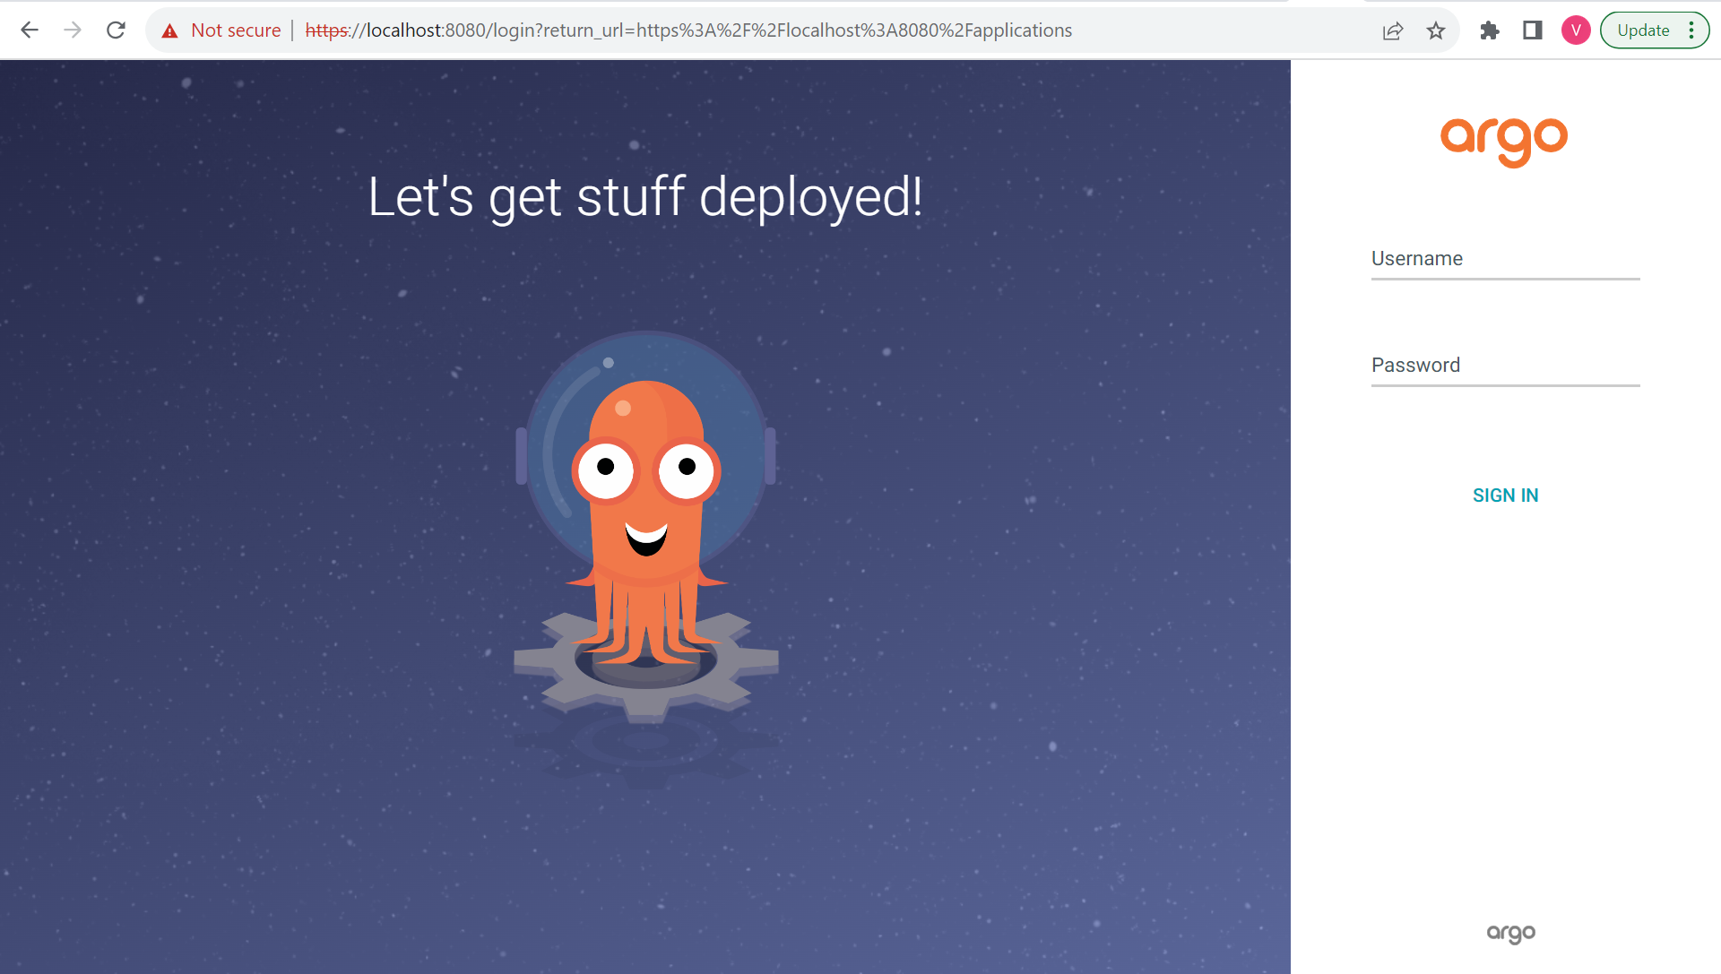

Step 5: Login

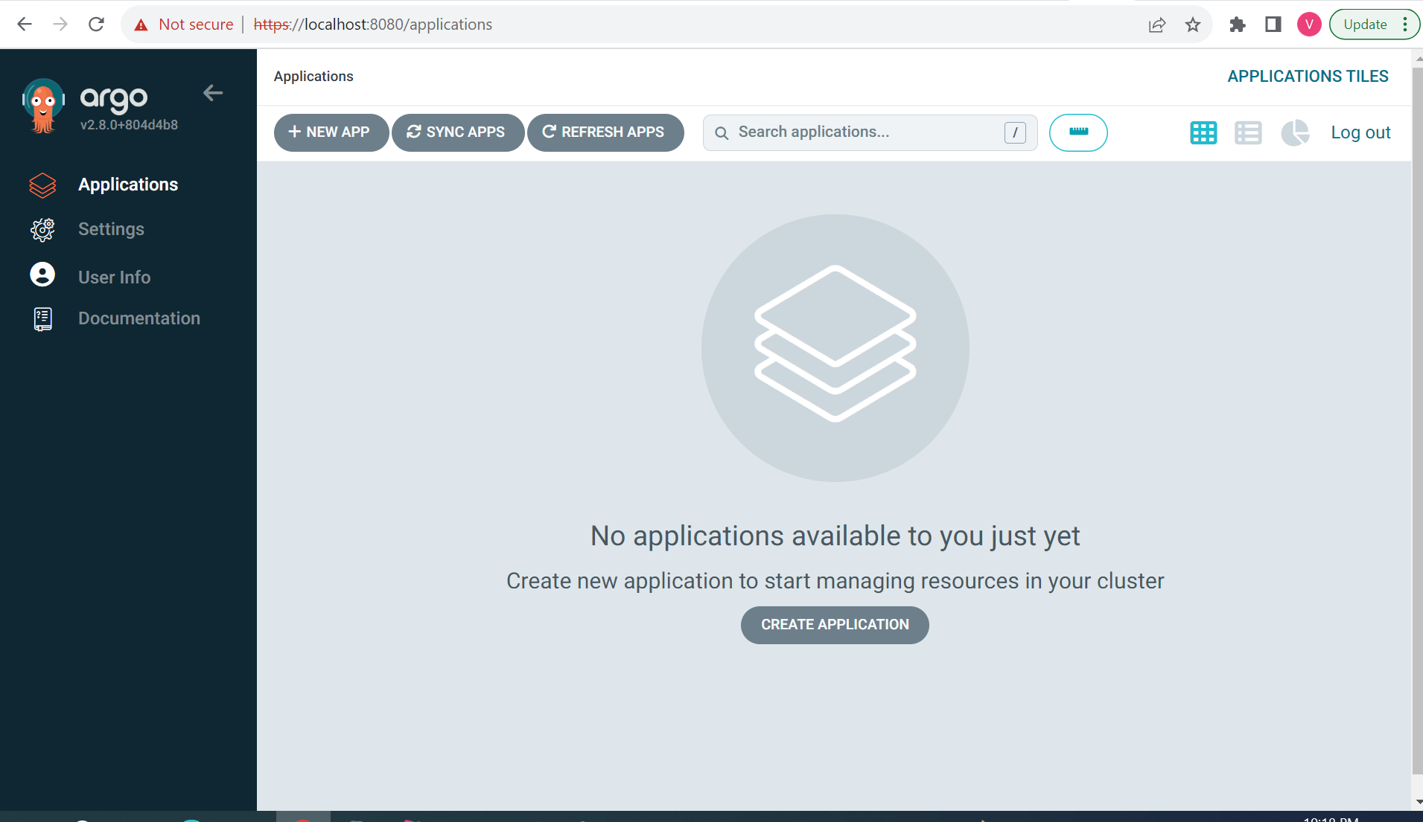

Step 6: Create app-argocd namespace



Step 7: Create a project

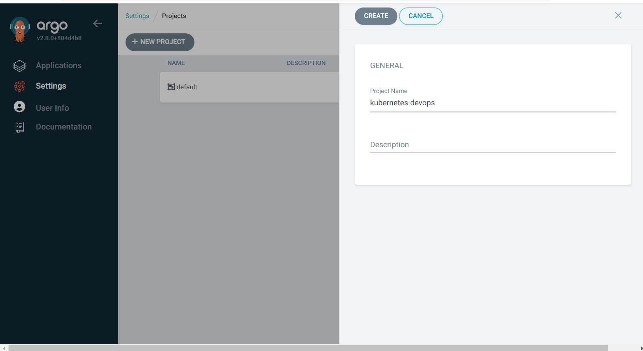

Step 8: Add source repo, destination, cluster resource allow list

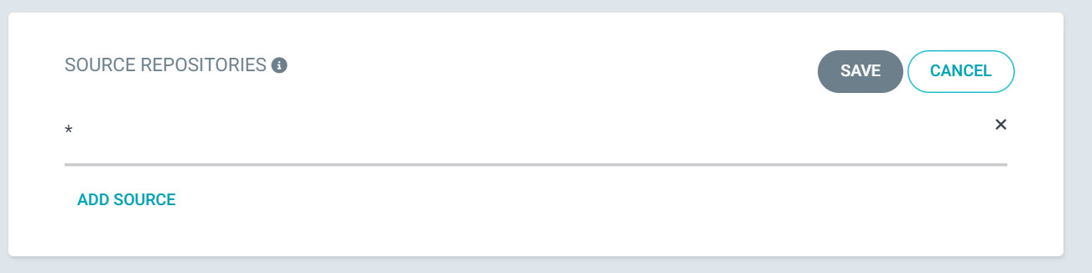

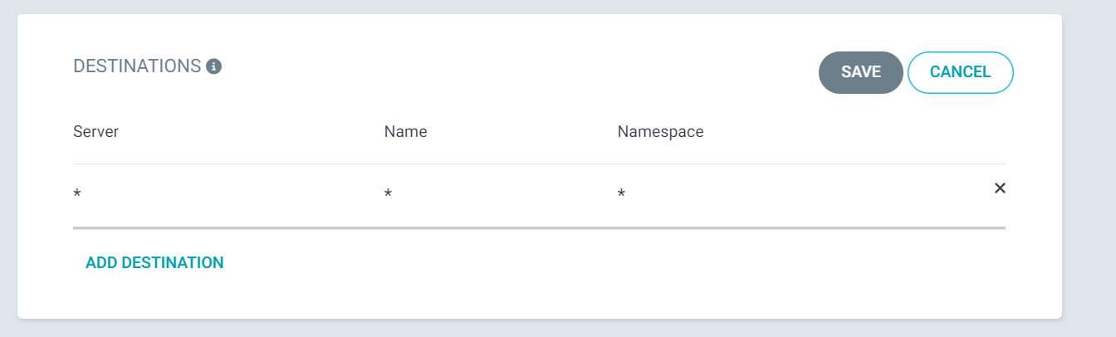

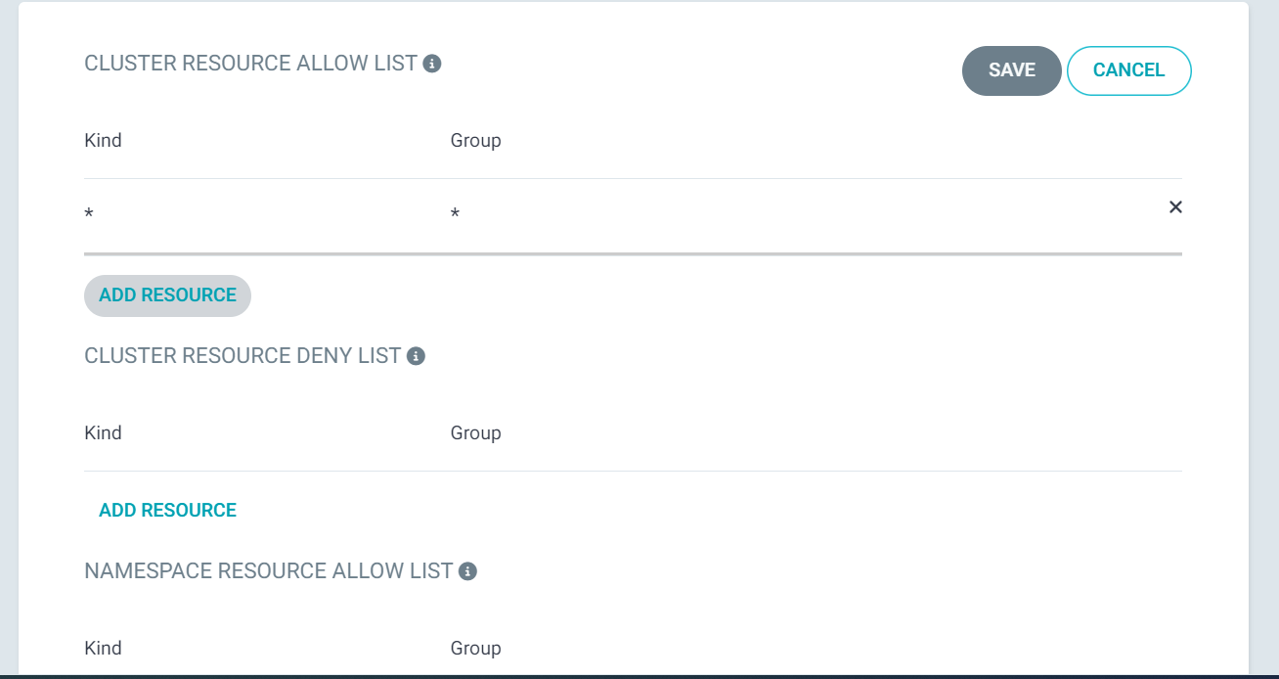

Step 9: Create app

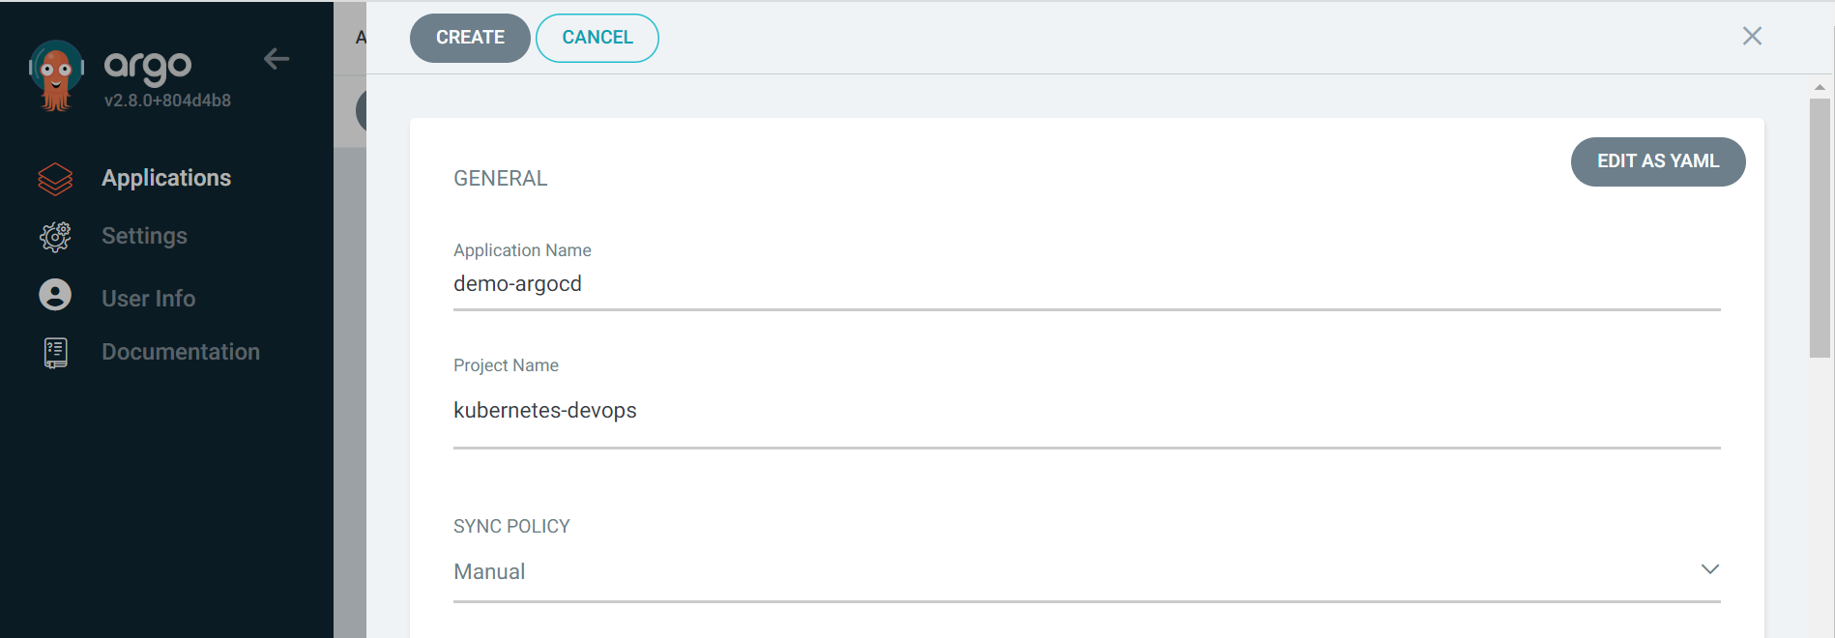

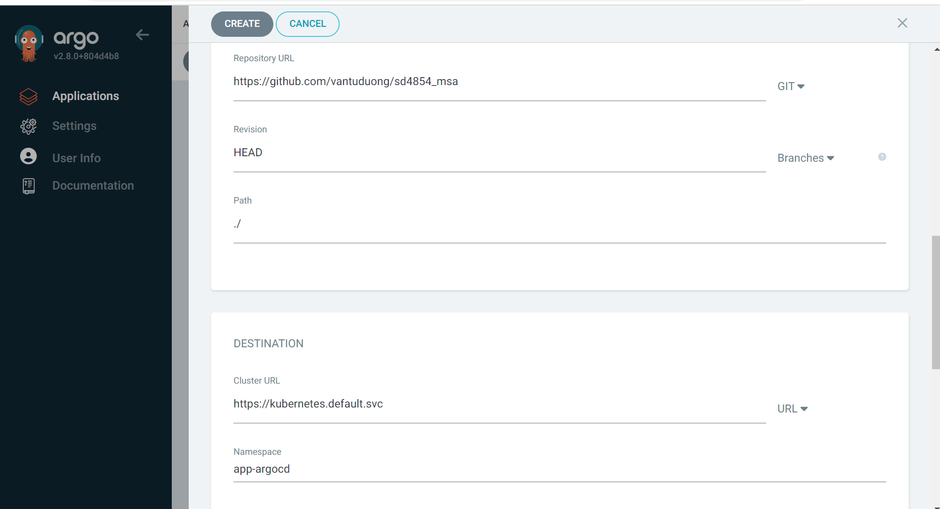

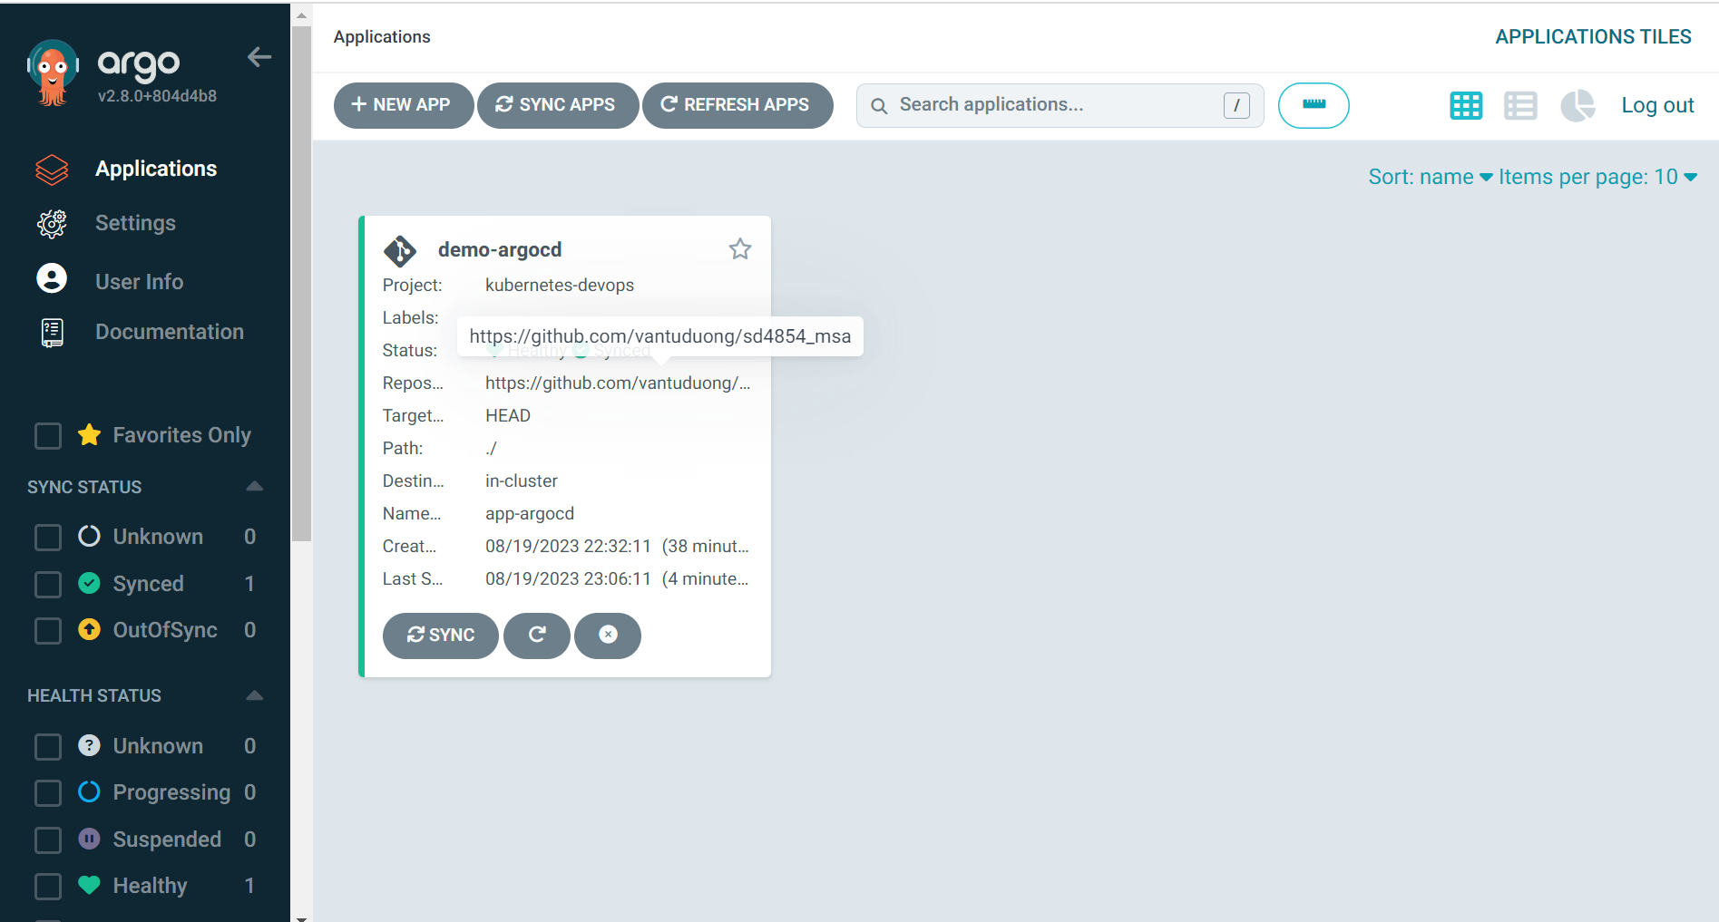

Step 11: Run application

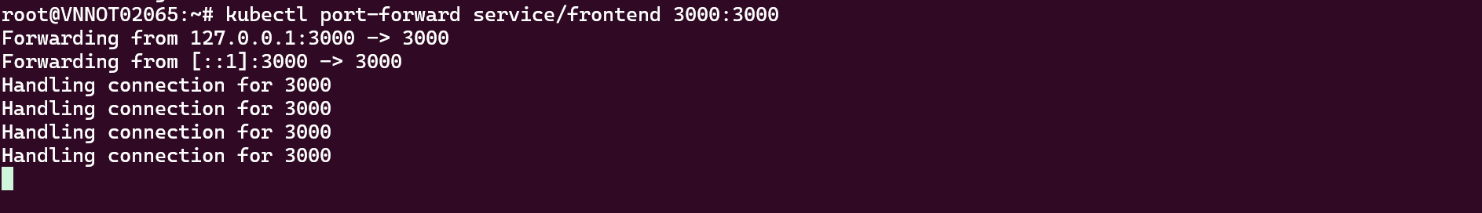

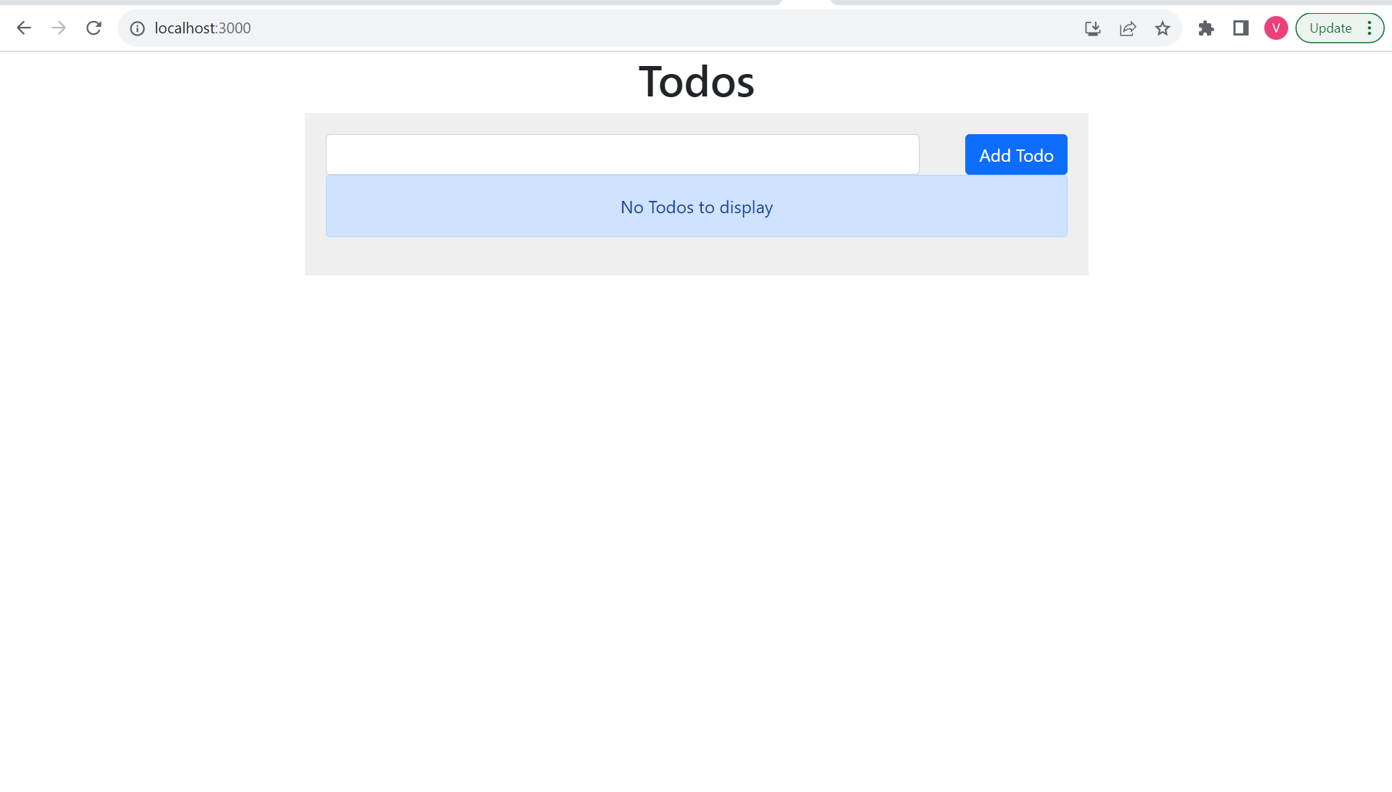

Step 11: Update Jenkins file and frontend.yaml

* Remove CD scripts
* Push frontend image with tag **v2**
* Change image tag from **v1** to **v2**

Step 12: Resync argocd

